Table of Contents Pages
- Introduction………………………………………………………………………2-3
- Software Development Life Cycle (SDLC)………………………………4-6
- System Architecture Design……………………………….………………..7-9
- UML Diagrams……………………………………………………………………10-12
- Prototype Development…………………………………………..………….12-16
- Project Management…………………………………………………..……..11-18
- License, Design Quality and SDG Relevance…………….……………..19-20
- GitHub Repository……………………….……………………………………….21-23
- Conclusion…………………………………………………..………………..…….24
- References……………………………………………………….……………..….25

- Introduction
This report presents the final software design for WorkConnect SL, a Digital Public Good system developed.
WorkConnect SL directly addresses United Nations Sustainable Development Goal 8: Decent Work and Economic Growth. The system targets three critical SDG 8 targets: Target 8.5 achieving full and productive employment for all; Target 8.6 reducing the proportion of youth not in employment, education, or training; and Target 8.8 protecting labor rights and promoting safe working environments.
In Sierra Leone, particularly in urban centers like Freetown, youth unemployment remains critically high at over 60% (ILO, 2023). Many young people lack access to verifiable job opportunities, skills development pathways, or mechanisms to report unsafe working conditions. The informal sector, which employs most workers, often operates without labor protections or wage security. WorkConnect SL addresses this by providing a hybrid digital platform that uses both smartphone apps and USSD *888# access to crowdsource job listings, verify skills, map employment hotspots, and enable anonymous workplace safety reporting.

1.1 Problem Definition
Sierra Leone faces a critical youth employment crisis that directly undermines SDG 8. According to the International Labor Organization, youth unemployment exceeds 60%, with most young people trapped in vulnerable informal work that lacks job security, fair wages, or safety protections (ILO, 2023). Three structural gaps persist:
Access Gap: Young job seekers cannot easily find or verify employment opportunities. Most jobs are shared by word-of-mouth or through exploitative middlemen who charge fees. There is no centralized, trusted platform connecting employers with skilled youth.
Safety Gap: Workers in construction, transport, and market trading frequently experience unsafe working conditions, wage theft, and harassment. Yet there is no accessible, anonymous mechanism to report violations to the Ministry of Labor and Social Security.
Data Gap: The Government of Sierra Leone lacks real-time, verifiable data on job creation, sector-specific hiring trends, or workplace safety incidents. Current employment statistics rely on outdated annual surveys, making it difficult to design targeted interventions or measure progress toward SDG 8 targets.
Target Users
WorkConnect SL serves four primary user groups:
Job Seekers: Unemployed and underemployed youth aged 15–35, particularly in Freetown and other urban centers. This includes secondary school graduates, university students, and informal workers seeking stable, decent employment.
Employers: Small and medium enterprises, NGOs, construction firms, and service providers who need a low-cost, trusted way to advertise vacancies and verify applicant skills.
Labor Officers: Staff at the Ministry of Labor and Social Security who need real-time data to monitor employment trends and respond to workplace safety violations.
System Admins: Technical administrators who manage user accounts, approved employer registrations, and maintain platform integrity.

- Software Development Life Cycle (SDLC)
WorkConnect SL will be developed using the Agile Software Development Life Cycle model. Agile was selected because it supports iterative development, continuous feedback from users, and rapid adaptation to changing requirements all critical for a public-facing platform serving diverse user groups with varying digital literacy in Sierra Leone.
Agile development is organized into short iterations called Sprints, each lasting two to four weeks. This allows the team to deliver working features incrementally while continuously improving the system based on user feedback. The following describes how each Agile phase applies to WorkConnect SL:
  - Phase 1: Planning and Requirements
In this phase, the project team identifies all stakeholders including youth job seekers, employers, Labor Officers at the Ministry of Labor and Social Security, and System Admins. Stakeholder interviews and focus groups are conducted in Freetown communities such as Kroo Bay and Congo Cross to understand real-world employment challenges.
The Product Backlog is created, listing all system features prioritized by business value. High-priority items include user registration via USSD and app, job search and mapping, anonymous workplace safety reporting, and the Ministry of Labor dashboard. Acceptance criteria are defined for each user story to ensure testable outcomes.
  - Phase 2: System Design
The architecture of WorkConnect SL is designed in this phase. The system adopts a three-tier client-server architecture comprising a front-end mobile and web application, a RESTful API backend, and a relational database. UML diagrams including the Use Case Diagram and Class Diagram are produced to model system behavior and structure.
The UI/UX design is produced in Figma, covering all key screens including onboarding, job search with map view, job application, workplace safety reporting, employer dashboard, and the Ministry of Labor analytics dashboard. The USSD interaction flow for *888# is also designed to serve users without smartphones.
  - Phase 3: Sprint Development
Development proceeds in four two-week Sprints, each delivering working software increments:
Sprint 1: User authentication (app and USSD *888#), profile creation, and database setup.
Sprint 2: Job listing, search with map view, and employer job posting module.
Sprint 3: Anonymous workplace safety reporting, Labor Officer dashboard, and employer verification workflow.
Sprint 4: SMS job alerts, employment analytics dashboard, system testing, and performance optimization.
Each Sprint includes daily stand-up meetings, a Sprint Review to demonstrate features to stakeholders, and a Sprint Retrospective to identify improvements for the next Sprint.
  - Phase 4: Testing
Testing is integrated throughout each Sprint using a combination of unit testing, integration testing, and user acceptance testing (UAT). Unit tests verify individual components such as the job search filter and safety report submission. Integration tests confirm that the frontend, API, and database communicate correctly. UAT is conducted with real users’ youth job seekers and Labor Officers in Freetown to validate usability and functionality.
Performance testing ensures the system handles concurrent users during peak periods. Security testing verifies that anonymous safety reports cannot be traced back to the reporter, protecting whistleblowers as required under Target 8.8.
  - Phase 5: Deployment
WorkConnect SL is deployed in stages. The initial pilot targets Freetown, with the system hosted on a cloud server accessible via the web app and USSD gateway. Deployment uses a Continuous Integration and Continuous Deployment (CI/CD) pipeline managed through GitHub Actions, ensuring rapid and reliable releases after each Sprint.
The USSD *888# service is integrated with a local Sierra Leone telecom partner to ensure nationwide accessibility, including for users in rural areas without smartphone or internet access.
  - Phase 6: Maintenance
Following the initial pilot, the system enters a maintenance phase where bugs are patched, features are refined based on user feedback, and the system is scaled to support additional districts beyond Freetown. Monthly releases are planned, with the Product Backlog continuously updated to reflect new user needs and government reporting requirements.

- System Architecture Design
WorkConnect SL is designed using a three-tier client-server architecture. This architecture separates the system into three logical layers: Presentation, Application Logic, and Data, each responsible for distinct functions. This separation improves maintainability, scalability, and security.
  - Architecture Overview
The three tiers operate as follows:
Tier 1: Presentation Layer (Frontend): The user-facing layer consists of a React Native mobile app for Android and iOS, a React.js web application for desktop browser access, a dedicated Admin Portal for Labor Officers and System Admins, and a USSD gateway serving users dialing 888# on any mobile phone.
Tier 2: Application Logic Layer (Backend API): A Node.js REST API processes all business logic. It handles authentication, job matching algorithms, safety report encryption, employer verification workflows, and SMS notification dispatch. The API communicates with the frontend via HTTPS and with the database via secure database drivers.
Tier 3: Data Layer (Database): A PostgreSQL relational database stores all persistent data including user profiles, job listings, applications, safety reports, and employment statistics. The database is hosted on a secure cloud server with regular automated backups.
  - Architecture
The following diagram describes the system architecture of WorkConnect SL.
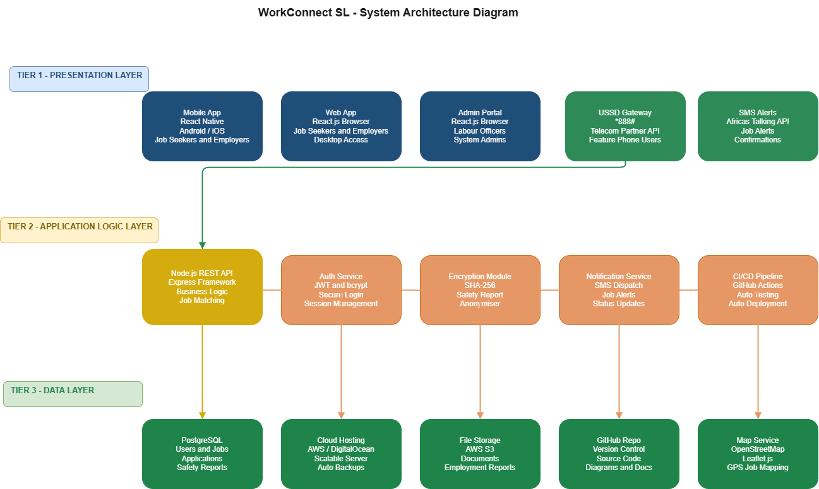

Component | Technology | Purpose
Mobile App | React Native | Android/iOS app for job seekers and employers
Web App | React.js | Browser-based access for Labor Officers and Admins
USSD Gateway | *888# via Telecom API | Feature phone access for rural and low-income users
Backend API | Node.js + Express | Business logic, authentication, notifications
Database | PostgreSQL | Persistent storage of all system data
SMS Service | Africa's Talking API | Job alerts and report confirmations via SMS
Map Service | OpenStreetMap + Leaflet | GPS-based job mapping and safety incident mapping
Authentication | JWT + bcrypt | Secure token-based user sessions
Cloud Hosting | AWS / DigitalOcean | Scalable server infrastructure
CI/CD Pipeline | GitHub Actions | Automated testing and deployment

  - Component Interactions
The components interact in the following sequence for the primary job application workflow:
- The Job Seeker opens the mobile app or dials *888# and authenticates using their phone number and PIN. The frontend sends credentials to the Node.js API over HTTPS.
- The Node.js API validates credentials against the PostgreSQL database using bcrypt password hashing and returns a JWT authentication token.
- The authenticated user searches for jobs. The app sends a search request with location and skill filters to the API. The API queries PostgreSQL for matching vacancies and returns results with GPS coordinates.
- The map layer (OpenStreetMap/Leaflet) renders job locations visually on the mobile app. The user selects a vacancy and applies. The API stores the application in PostgreSQL and notifies the Employer via SMS through Africa's Talking API.
- The Employer logs into the web app, reviews applications, and updates the job status. The API sends an SMS notification to the Job Seeker confirming interview or outcome.
- For safety reports, the API encrypts the reporter's identity before storing the report in PostgreSQL, ensuring full anonymity. The Labor Officer dashboard receives an alert and can investigate via the web app.

- UML Diagrams
  - Use Case Diagram
The Use Case Diagram below models the interactions between all four actors and the system functions of WorkConnect SL.
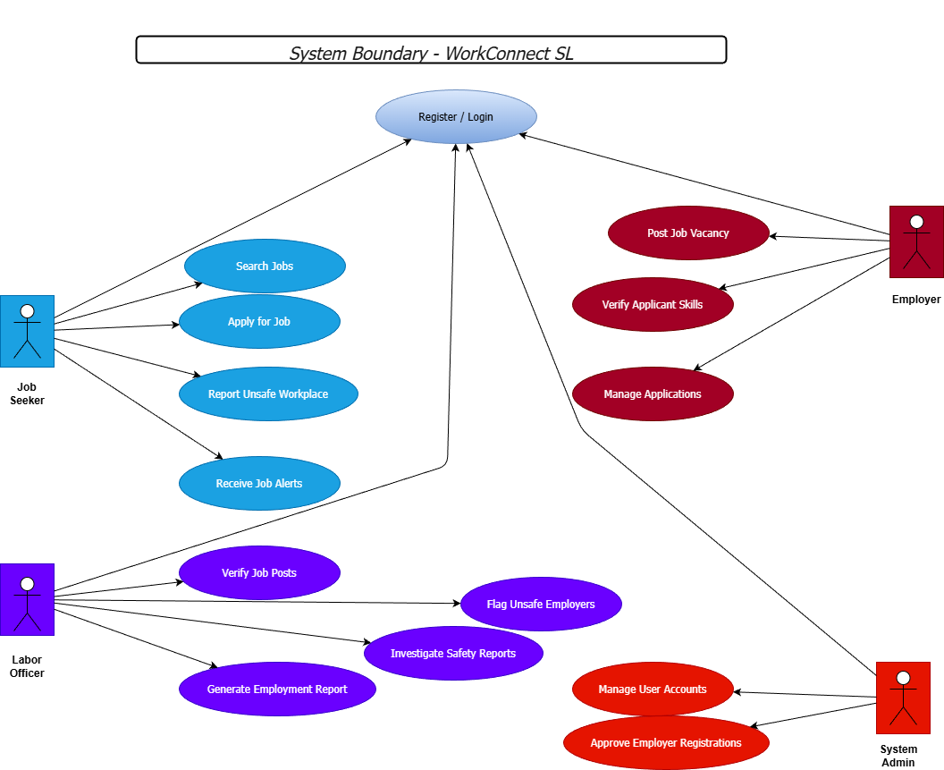

Actor | Use Cases
Job Seeker | Register/Login, Search Jobs, Apply for Job, Report Unsafe Workplace, Receive Job Alerts
Employer | Register/Login, Post Job Vacancy, Verify Applicant Skills, Manage Applications, Close Vacancy
Labour Officer | Login, Verify Job Posts, Investigate Safety Reports, Flag Unsafe Employers, Generate Employment Report
System Admin | Manage User Accounts, Approve Employer Registrations, Monitor System Health
  - Class Diagram
The Class Diagram models show the key entities in the WorkConnect SL system and their relationships.
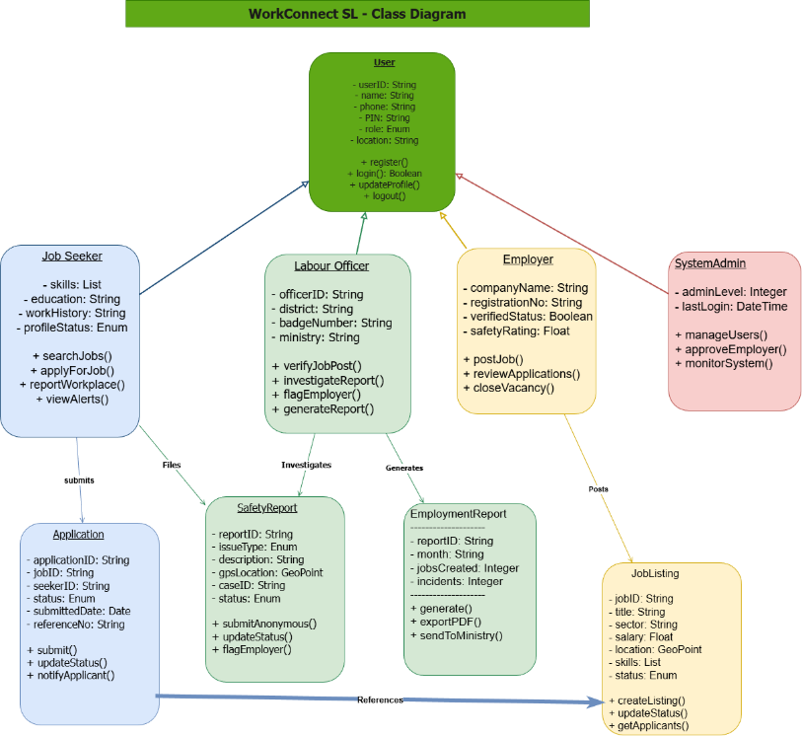

Class | Key Attributes | Key Methods
User | userID, name, phone, PIN, role, location | register (), login(), updateProfile()
JobSeeker | skills, education, workHistory, profileStatus | searchJobs(), applyForJob(), reportWorkplace()
Employer | companyName, registrationNo, verifiedStatus | postJob(), reviewApplications(), closeVacancy()
LabourOfficer | officerID, district, badgeNumber | verifyJobPost(), investigateReport(), generateReport()
JobListing | jobID, title, salary, location, skills, status | createListing(), updateStatus(), getApplicants()
Application | applicationID, jobID, seekerID, status, date | submit (), updateStatus (), notify()
SafetyReport | reportID, issueType, description, GPS, caseID | submitAnonymous(), updateStatus(), flagEmployer()
EmploymentReport | reportID, month, jobsCreated, incidents | generate(), export(), sendToMinistry()

- Prototype Development
The WorkConnect SL prototype is designed in Figma, consisting of twenty-one key screens that demonstrate the complete user journey for all four actor types (Job Seekers, Employers, Labor Officers, and System Administrators). The prototype follows a responsive desktop-first design approach for laptop users while maintaining accessibility and usability standards suitable for deployment in Sierra Leone. The design system uses a consistent color palette Navy Blue (1F4E79) for primary actions, Green (2E8B57) for confirmation and success states, and White/Light Grey for backgrounds, ensuring accessibility and readability in outdoor environments with varying screen brightness.
  - Figma Screen Descriptions

Screen No. | Screen Name | Actor | Description
1 | Splash Screen | All Users | Welcome screen displaying the WorkConnect SL logo, tagline, and options to Register or Login. Includes USSD access information (*888#).
2 | Login | All Users | User authentication screen with phone/email and password fields, login button, and registration link.
3 | Registration | Job Seeker | Account creation screen with role selection (Job Seeker, Employer, Labour Officer), phone number, and password setup.
4 | Job Seeker Dashboard | Job Seeker | Main dashboard showing recommended jobs, categories, notifications, and quick access to job search features.
5 | Search Jobs | Job Seeker | Search interface allowing users to search vacancies by keyword, location, and category.
6 | Job Search Results | Job Seeker | Displays filtered job vacancies with employer name, salary range, and job category.
7 | Job Details | Job Seeker | Detailed vacancy information including job description, requirements, employer details, and Apply Now button
8 | Application Success | Employer | Confirmation screen displayed after successful job application submission.
9 | My Applications | Employer | Displays all jobs applied for by the user and tracks application status.
10 | Employer Dashboard | Employer | Overview of active vacancies, applications received, and recruitment statistics.
11 | Manage Jobs | Employer | Allows employers to view, edit, delete, and monitor posted vacancies.
12 | Post New Job | Employer | Form for creating and publishing a new vacancy including salary, location, and job requirements.
13 | Applicant Details | Employer | Displays applicant information, qualifications, and application status.
14 | Labour Officer Dashboard | Labour Officer | Dashboard showing employment trends, incident reports, and monitoring tools.
15 | Report Unsafe Workplace | Labour Officer / Job Seeker | Form used to report unsafe working conditions, wage theft, harassment, or labour violations
16 | Safety Reports List | Labour Officer | List of submitted workplace safety reports with filtering and review options.
17 | Employment Analytics | Labour Officer | Interactive dashboard displaying employment statistics, hiring trends, and workplace safety metrics.
18 | Admin Dashboard | System Admin | Administrative control panel showing platform statistics and system management tools.
19 | Manage Employers | System Admin | Interface for verifying, approving, or suspending employer accounts.
20 | Manage Users | System Admin | User management screen for viewing, editing, and monitoring registered users.
21 | Audit Logs | System Admin | Displays system activities, administrative actions, login records, and security events.

Each screen includes placeholder annotations in the Figma file explaining design decisions, including accessibility considerations for low-literacy users and the rationale for USSD parity every smartphone screen has an equivalent USSD *888# menu flow.

FIGMA DESIGN SCREEN PHOTOS
Mobile App View
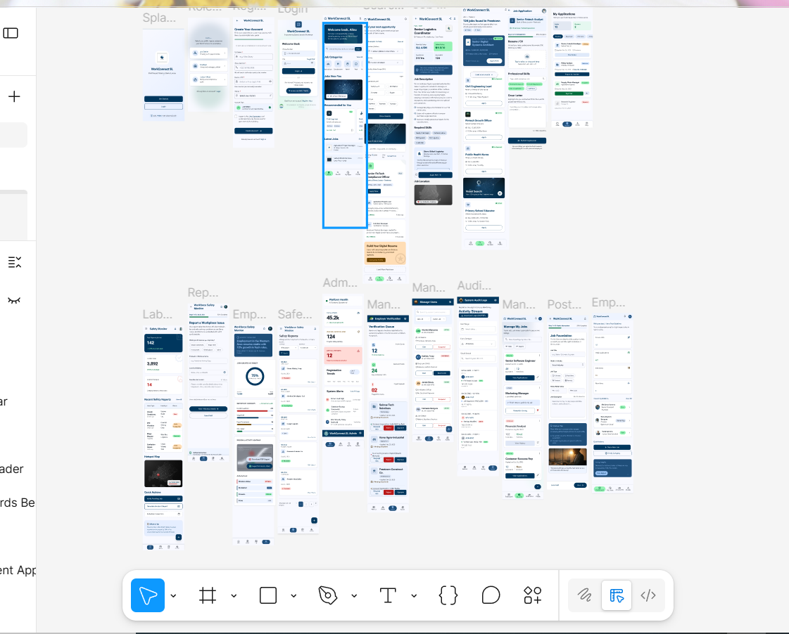

Desktop View
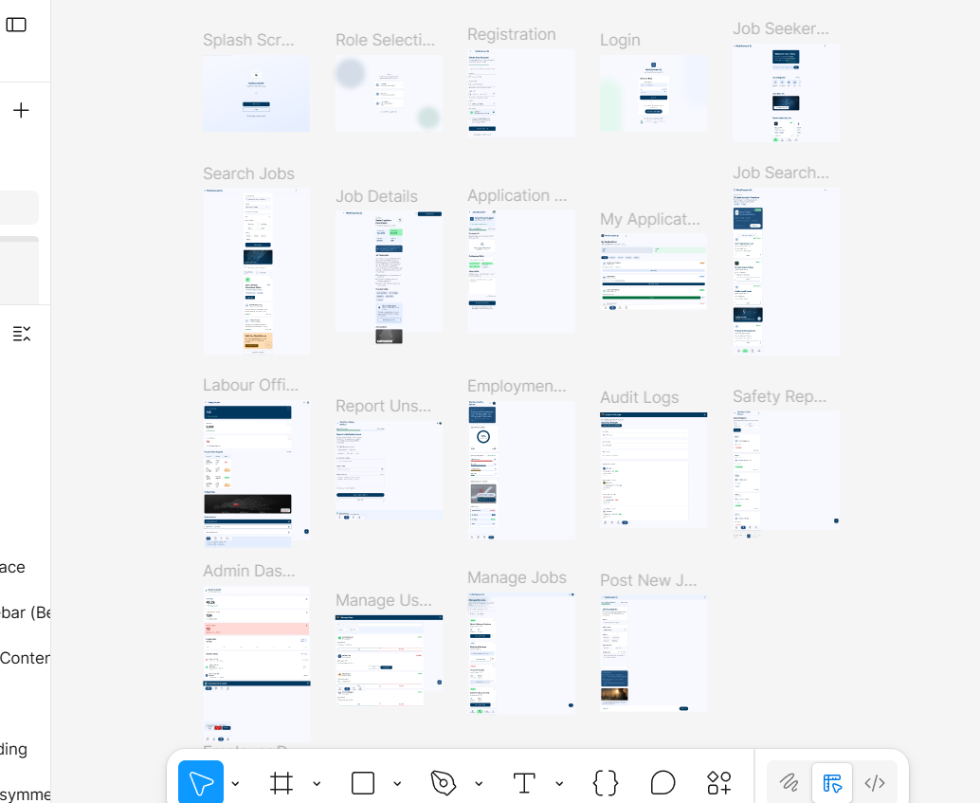
- Project Management
  - Gantt Chart
The Gantt chart below outlines the project timeline across an 11-week development schedule aligned with the academic semester.
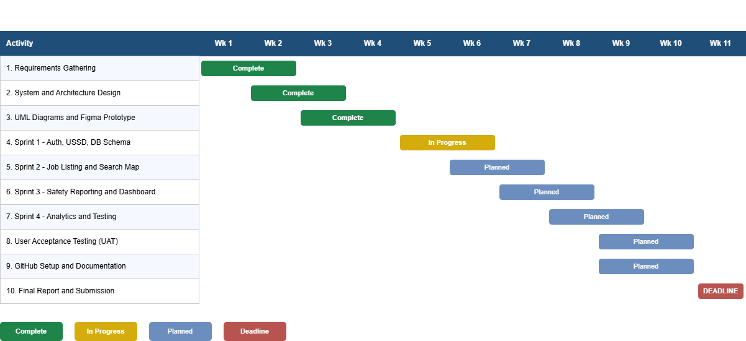

Week | Activity | Status
Week 1–2 | Project Planning, Stakeholder Analysis, Requirements Gathering | Complete
Week 3–4 | System Design, Architecture Design, UML Diagrams, Figma Prototype | Complete
Week 5–6 | Sprint 1: User Auth, USSD Setup, Database Schema | In Progress
Week 6–7 | Sprint 2: Job Listing, Search Map, Employer Job Posting | Planned
Week 7–8 | Sprint 3: Safety Reporting, Labor Officer Dashboard, SMS Alerts | Planned
Week 8–9 | Sprint 4: Analytics Dashboard, UAT, Performance Testing | Planned
Week 9–10 | GitHub Repository Setup, Documentation, Final Report Writing | Planned
Week 11 | Final Submission, GitHub Upload, Presentation Preparation | Planned

  - Network Diagram (Critical Path)
The Network Diagram illustrates the Critical Path for WorkConnect SL development.
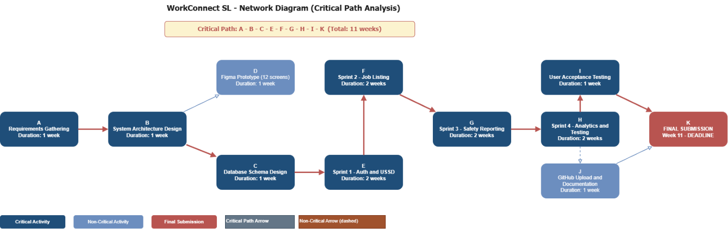
The critical path runs through: Requirements → Architecture Design → Database Schema → Backend API Development → Integration Testing → UAT → Deployment. Any delay in these activities directly impacts the final submission deadline. Parallel activities such as Figma prototype design and USSD flow design are not on the critical path but feed into Sprint 2 and Sprint 3 respectively.

Activity | Duration | Depends On | Critical?
A: Requirements Gathering | 1 week | - | Yes
B: System Architecture Design | 1 week | A | Yes
C: Database Schema Design | 1 week | B | Yes
D: Figma Prototype (12 screens) | 1 week | C | No
E: Sprint 1 — Auth & USSD | 2 weeks | D | Yes
F: Sprint 2 — Job Listing & Search | 2 weeks | E | Yes
G: Sprint 3 — Safety Reporting | 2 weeks | F | Yes
H: Sprint 4 Analytics & Testing | 2 weeks | G | Yes
I: UAT with Real Users | 1 week | H | Yes
J: GitHub Upload & Documentation | 1 week | H | No
K: Final Submission | - | I, J | Yes

- License, Design Quality and SDG Relevance
  - Software License
WorkConnect SL is licensed under the MIT License. This license was selected for the following reasons:
- The MIT License allows anyone to freely use, copy, modify, merge, publish, and distribute the software, with or without modification, provided the original copyright notice and permission text is included.
- As a Digital Public Good, WorkConnect SL must be openly accessible to governments, NGOs, and developers in Sierra Leone and other developing nations who may wish to adapt the platform for their own labour markets.
- The MIT License is compatible with the Digital Public Goods Standard, which requires open-source licensing for DPG certification.
- External resources used in the system, including Africa's Talking API (commercial API with free tier), OpenStreetMap (ODbL license), and React Native (MIT License), are properly attributed in the system documentation and README file on GitHub.

MIT License Copyright (c) 2026 WorkConnect SL. Permission is hereby granted, free of charge, to any person obtaining a copy of this software and associated documentation files, to deal in the Software without restriction, including without limitation the rights to use, copy, modify, merge, publish, distribute, sublicense, and/or sell copies of the Software, subject to the following conditions: The above copyright notice and this permission notice shall be included in all copies or substantial portions of the Software.
  - Design Quality (UI/UX)
The WorkConnect SL interface is designed for the following quality standards:
Accessibility: All screens meet WCAG 2.1 AA contrast ratios. Text is minimum 16sp on mobile. Icons are accompanied by text labels to support low-literacy users, a critical consideration given Sierra Leone's adult literacy rate of approximately 48%.
Consistency: A unified design system is applied across all 21 Figma screens using standardized typography (Roboto), color tokens (Navy #1F4E79, Green #2E8B57), spacing (8px grid), and reusable component patterns.
Navigation: Bottom navigation bar with four items (Search, Alerts, Profile, Report) ensures key functions are reachable within two taps from any screen. Progressive disclosure is used in complex forms to avoid overwhelming users.
USSD Parity: Every core function available in the smartphone app has an equivalent USSD *888# menu flow, ensuring users without internet access are not excluded from the platform's benefits.
  - SDG Relevance
WorkConnect SL directly supports SDG 8: Decent Work and Economic Growth across three measurable targets:
Target 8.5: Full and Productive Employment: The real-time job mapping feature gives youth job seekers in Freetown and rural districts immediate access to verified employment opportunities, reducing time and cost of job searching. The skills verification feature increases employer confidence in applicants, improving hiring rates.
Target 8.6: Reduce Youth Not in Employment: Job alert notifications and integrated links to skills training programs directly support youth progression from informal to formal employment, reducing the percentage of youth not in employment, education or training.
Target 8.8: Protect Labor Rights: The anonymous workplace safety reporting module empowers informal workers to report wage theft, unsafe conditions, and harassment directly to the Ministry of Labor giving vulnerable workers a protected voice and holding employers accountable.
Additionally, WorkConnect SL supports the Government of Sierra Leone's National Employment Policy 2022–2026, which prioritizes youth job creation and private sector growth. The system's employment dashboard provides the Ministry of Labor with real-time data for national SDG 8 reporting and policy design.
- GitHub Repository
A GitHub repository has been created for WorkConnect SL to manage version control, team collaboration, and project file hosting.

  - Repository Structure

Folder/File | Contents
/docs | Final project report (PDF), system design rationale
/diagrams | draw.io XML files: Use Case, Class, Architecture, Gantt, Network Diagrams
/prototype | Figma export screenshots of all 12 screens
/src | Source code: server.js (main API), package.json (dependencies), database. SQL (PostgreSQL schema), routes/users.js (authentication), routes/jobs.js (job listings), routes/reports.js (safety reports). env.example (environment variables)
README.md | Project overview, setup instructions, SDG alignment, MIT license
LICENSE | Full MIT License text

8.2. Collaboration
The repository is set to Public to comply with the MIT open-source license and Digital Public Goods Standard. The course examiner (santigie.kamara@limkokwing.edu.sl) has been added as a collaborator with read access for assessment purposes. Commits are made using descriptive messages following the conventional commits standard (e.g., feat: add job search map view, fix: encrypt safety report before storage).
8.3 Backend Source Code
The backend source code is available in the /src folder of the GitHub repository. The API is built with Node.js and Express, comprising three route modules: users.js for authentication and profile management, jobs.js for vacancy search and application management, and reports.js for anonymous workplace safety reporting. The database schema (database. SQL) creates seven relational tables in PostgreSQL, fully aligned with the Class Diagram presented in Section 4 of this report.
The backend follows RESTful API design principles. Key security measures include bcrypt hashing for all user PINs, JSON Web Token (JWT) authentication for session management, and SHA-256 encryption for safety report identities, ensuring full anonymity as required by SDG 8 Target 8.8. The Africa’s Talking API is integrated in the notification service to dispatch SMS job alerts and application confirmations to users across Sierra Leone, including those without internet access.

- Conclusion
WorkConnect SL demonstrates how Digital Public Goods can directly accelerate progress toward SDG 8: Decent Work and Economic Growth in Sierra Leone. By leveraging crowdsourced job mapping, skills verification, and anonymous workplace reporting, the system tackles three structural barriers: youth unemployment, unsafe working conditions, and the lack of real-time labor market data for government policy.
The system is designed using the Agile SDLC model, ensuring iterative development and continuous feedback from real users in Freetown communities. The three-tier architecture combining React Native, Node.js, and PostgreSQL provides a scalable, maintainable foundation. The USSD *888# integration ensures the platform is inclusive, reaching citizens in low-connectivity areas and aligning with the 2030 Agenda principle of leaving no one behind.
The MIT open-source license ensures WorkConnect SL can be freely adapted by governments and NGOs across Sierra Leone and beyond, maximizing its impact as a replicable model for addressing youth unemployment in developing nations. Future work will include piloting the system in Freetown's Kroo Bay and Congo Cross communities, partnering with the Ministry of Labor for employer verification, and integrating with national skills training programs to support Target 8.6.

- References
Fowler, M. (2004). UML Distilled: A Brief Guide to the Standard Object Modeling Language. 3rd ed. Boston: Addison-Wesley.
Government of Sierra Leone, Ministry of Labor and Social Security. (2022). National Employment Policy 2022–2026. Freetown: Government of Sierra Leone.
International Labor Organization. (2023). World Employment and Social Outlook: Trends 2023. Geneva: ILO.
Pressman, R.S. and Maxim, B.R. (2020). Software Engineering: A Practitioner's Approach. 9th ed. New York: McGraw-Hill.
Sommerville, I. (2016). Software Engineering. 10th ed. Boston: Pearson.
United Nations. (2015). Sustainable Development Goal 8: Promote sustained, inclusive and sustainable economic growth, full and productive employment and decent work for all. Available at: https://sdgs.un.org/goals/goal8 [Accessed 1 June 2026].
World Bank. (2024). Sierra Leone Economic Update: Unlocking Youth Employment. Washington, DC: World Bank Group.

